**Experiment 28**

**AIM :**

To design DFA transition diagram of even c’s in automata.

**Design and output:**

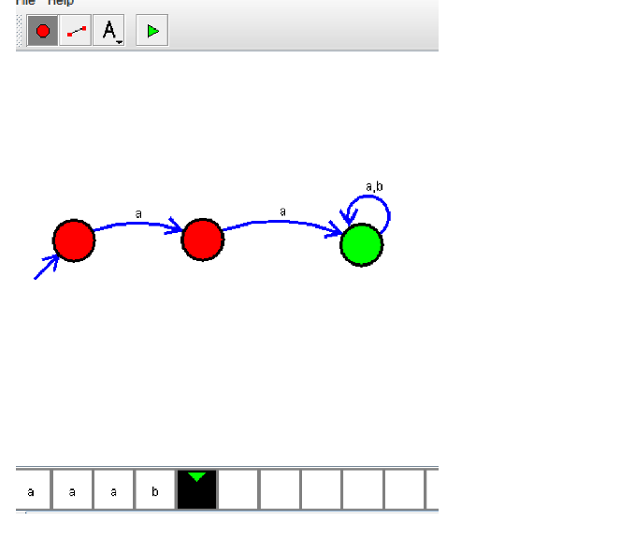

**Result:** Thus designing DFA of even c’s is done and verified by giving sample inputs of even number of c’s